The Incidence and Intensity of Post-Vaccination Emission of Electro-Magnetic Effects and Radio Frequencies after Vaccination against Covid-19
by SG The Magnetic Group
Abstract
This study aims to
a) identify persons who have become magnetic after receiving the Covid-19 vaccines or had interactions with Covid-19 vaccinated persons at work or at home.
b) find and apply methods and instruments to measure and record the incidence of magnetic attractions and the intensity of the emissions of magnetic fields and the intensity of radio frequencies from persons after vaccinations against Covid-19.
Testing began in mid June 2021 and were first recorded on 19 July 2021. By the end of Nov 2021, we collated 44 cases of persons demonstrating electro-magnetic effects i.e. magnetic attractions and emissions of radio frequencies.
Cases 45 to 48 are 3 unique cases of unvaccinated individuals who do not demonstrate electro-magnetic effects, serving as controls for this study.

1 Introduction
As the number of Covid-19 vaccinations increased globally from Dec 2020, the internet saw reports of vaccinated persons and unvaccinated persons experiencing magnetic effects - the ability to attract magnets, magnetic objects and non-magnetic metallic objects including but not limited to the upper arms, chest and forehead. Scientists worldwide began studying this phenomenon in random controlled research environments [1,2] and analysed the contents of the Covid-19 vaccine vials [10,14,16].
In the middle of 2021, a Chinese newspaper in Singapore made a report of this phenomena, causing local Singaporeans to start self-administering magnet tests and sharing their results online.
From 19 Jul 2021 to 26 Nov 2021, our group – consisting of a few researchers – started actively testing members of public and recorded a total of 44 cases (note that Case 9 reported 2 persons) comprising of 12 cases (27.3 %) unvaccinated while 32 cases (72.7 %) are partially or fully vaccinated, including one lady having had received the 3rd Covid-19 vaccine in the form of a booster shot (case 35).

2 Material and Methods
Various methods were applied, and instruments were utilized to measure the magnetic fields intensity, the electric field intensity and finally the intensities of radio frequencies emitted by the persons effected after they were first identified by tests using metallic objects and magnets.

2.1 Material and Instruments
To identify persons with magnetic effects, metallic objects like fridge magnets, button magnets including neodymium, coins, metallic keys, metallic rulers, metallic scissors, iron filings in casing, and loose staples were used.
The following instruments were later utilized to measure and record the strength of magnetic fields, electric fields, electromotive force (in mV) and radio frequencies: Digital Multimeter CD800F, Duka Pen Type Digital Multimeter DLBS-600.

2.2 Methods and Results
Important cases of each of the methods from the documentation on the Telegram Channel SG The Magnetic Group [https://t.me/SgTheMagneticGroup] are discussed. The multi-field meter Tenmars TD 190 measures the intensities of magnetic fields in x,y,z direction and the resultant in either mT or uG; the intensities of electric field in V/m; and of the intensities of the radio frequencies (RF) in uWm⁻² .

Use of a metallic dining spoon and magnetic field meter
Case 1: On 16 June 2021, an unvaccinated male living with 2 vaccinated family members was able to attract a metallic tablespoon on his chest near the heart. (Appendix 6) On 15 July 2021, he found that his forehead could attract a $1 coin and a metal key on the left and right frontal bones but not at the centre. A multi-fields meter (Tenmars TD 190) gave a magnetic field reading of 90 mTesla (mT) on the forehead spots, with a background reading of 1.0 mT. He complained of about 5 bouts of headaches in June, one bout lasting for a week. He also reported that the magnetic attraction was less after taking a shower. [18]
Case 5: A vaccinated male who received Pfizer shots in March and April 2021, was tested and found to attract a metal dining spoon strongly on his upper arms bilaterally. In addition, adverse effects of discomfort felt in his eyes were reported. At home, he tested and found out that his wife could attract metallic objects as well. Both persons work as private hire drivers full-time in the evening in Singapore. We note that a car dashboard typically emits magnetic and electric fields while a mobile phone and transceiver in a car both emit radio frequencies.
Case 6: A vaccinated lady, who took the second Pfizer shot in May, was tested and found to attract a metal dining spoon. She also experienced tinnitus simultaneously.

Use of a card magnet
Case 2: On 22 July 2021, a lady vaccinated with two Moderna shots was found to attract a card magnet or a metal key at Beach Road. Adverse effects of pain and sleeplessness were reported.
Case 8: On 23 July 2021, a vaccinated male who received two Pfizer shots was tested and found to attract a card magnet on his bilateral deltoids and on his forehead. He complained of headaches which lasted for 10 days prior to testing.
Case 9.1: A vaccinated lady and her vaccinated husband (Case 9.2) were tested on 10th July 2021 and were found to attract a card magnet on their injection sites. This vaccinated lady reported that the strength of magnetic attractions varied from day to day and shifted locations on her body [28] e.g. stronger on arms for one day; stronger the next day on the abdomen. Possible reasons to such an observation include changes in the background radio frequencies and magnetic fields of her living environment resulting in movement of the magnetic particles and magnetic layers in her body [14].

Use of a fridge magnet
A video submitted by a man of his father (Case 3.1) and his grandmother (Case 3.2) showed them both being able to attract a card magnet and a long bottle-shaped fridge magnet at their deltoid region. These two persons were tested sometime in April 2021, where the tested persons were at 3 months post receiving their Covid-19 vaccines (Pfizer) and are among the earliest recorded cases of human magnetism post vaccination in Singapore.

Use of iron filings in plastic casing, loose staples
On 29 July 2021, a retest on Case 5 using a S$1 coin on his forehead that was cleaned with alcohol, showed different strengths of magnetic attraction. Tests done with iron filings in a casing and with loose staples showed no attraction. Possible reasons to this observation include: 1) Thickness of plastic casing, 2) ratio of weight to surface area of each iron filing and staple, and that 3) the attraction was by electromagnetic induction of the discharge of alternating currents and not by a constant magnetic field.

Use of a metallic knife, metallic key and metallic fork
Case 11: A vaccinated lady, who took the second Pfizer shot on 27th April 2021, attracted a metal knife on her left upper arm and had adverse effects of fever post vaccination.
Case 12: A vaccinated lady tested on 3rd July 2021 who received the Moderna jabs in May and July 2021, attracted a metallic key on her left upper arm.
Case 23: A vaccinated lady having taken both her Pfizer jabs in July and August 2021 respectively, attracted a metallic fork tightly on her left upper arm where she received her injections. Her magnetic attraction was observed to be stronger after her second Pfizer shot [9].

Use of a large metallic plate, metallic ruler
Case 29: A vaccinated helper who took the first shot of Pfizer in Sept 2021 was able to attract on her upper arm a metal fork, coins and a pair of small metal scissors. Acting upon a suggestion to test herself with something larger, the family was shocked when her arm attracted a large metal plate as shown in the photograph sent (Appendix 1). This is a demonstration of a high surface area to weight ratio affecting magnetism - where a large surface area of contact results in a stronger magnetic attraction.
Case 38: A vaccinated lady who took the Moderna shot was tested on 23rd October 2021 and could attract a large metallic plate or 2 metallic spoons on her right upper arm. She also complained of fatigue post vaccination.
Case 35: An elderly vaccinated lady, after receiving her booster shot on 24th November 2021, was tested on 26th November 2021 and could attract a metallic ruler on her face, back shoulder and upper arms. The booster shot had increased and spread the magnetic effects across her body significantly [7]. She also complained of nausea, a reduced ability to walk and strong headaches post booster shot.

Use of a Magnetic Field Intensity meter
Case 14: A vaccinated lady who took the Pfizer shot in June and July 2021, demonstrated changing emissions of magnetic field intensities. Maximal readings of 0.8 uG where recorded from her upper arms and hands at a background reading of 0.0 uG. These were recorded in video format (Appendix 2).

Use of a neodymium magnet
Case 16: A vaccinated lady who took the second shot of Sinovac in July 2021, was tested on 7th August 2021 and produced a video recording of her right upper arm strongly attracting a neodymium magnet. She reported having experienced dizziness and presenting with abnormal ECG waveforms after she received the first shot [8].
Case 17: An unvaccinated lady was tested on 6th August 2021 and was found to attract a neodymium magnet on her left upper arm. A video recording of the tests was made. She reported having experienced skin twitching on her whole body and sometimes she felt the nerves in her toes and hand ‘bend’ by themselves in June 2021. She works with vaccinated co-workers. This is an example of "vaccine shedding” or “transfection” [27].
Case 18: A video recording dated 8th August 2021 of a test done on a vaccinated lady who took the second Sinovac shot in July 2021, shows her attracting a neodymium magnet on her right upper arm despite having taken the shot on her left arm. Possible reasons to this phenomenon include the theory that the magnetic graphene oxide [8] from the Covid-19 vaccines can travel from the injection site to other parts of the body via the circulatory system [28].

Use of a Radio Frequencies meter TD190
Case 1: Testing was done on 7th September 2021 at 12 midnight on an unvaccinated but magnetic male with a radio frequency meter (Tenmars TD190). The device registered radio frequency (RF) intensities ranging from 200 to 1000 uW/m² from the knee joints of both his legs. Background RF was 30 uWm² at the point of testing. A retest at 5.50am with background RF at 17uW/m² registered the following results at his knee joints: a maximum of 8900 uW/m² over both knees while a maximum of 7400 uW/m² at his left leg. The tester’s mobile phone was kept on airplane mode throughout the video recording [4,5].

Use of Radio Frequencies meter, Sanwa mV meter CD800F, non-contact mV meter Duka DLBS600
Case 24: An unvaccinated lady who works with other vaccinated staff was tested on 11th September 2021. An SGD$1 coin was found to be attracted to the right, centre and left side of her forehead. (Appendix 7) Sanwa mV meter (CD800F) gave maximal AC rms readings of 29 mV on 2 points of her forehead. Non-contact mV meter (DLBS600) registered a maximum reading of AC 2.0 mV on her forehead, with initial readings of 0.0 mV [18]. A metallic dining spoon also attracted strongly on her right and left upper arms and the non-contact mV meter registered 0.0 mV.
The phenomenon of old SGD$1 coins (made of non-magnetic metal alloys) being attracted by affected persons is not due to simple magnetism but due to electro-magnetic induction, involving Faraday' Laws and Lenz's Law.
TD 190 registered a maximum of 200 uW/m² (5.6 times background RF) on the joints of this lady’s left and right legs with background RF at 36 mW/m². When she self-tested again in the evening, she could attract metallic objects on all previously tested spots including an additional spot on her chest.
Case 27: On 13th September 2021 at 11am, an unvaccinated male living with 2 vaccinated members of family produced a video demonstrating high RF emissions recorded from the medial aspect of both his knees. At a background RF of 300 uW/m², the Meter TD 190 that he was using registered RF intensities of up to 14,000 uW/m² (46.7 times background RF). Our team notes that the higher the intensities of background RF, the higher the emitted RF intensities will be [4].
Use of a large metallic key and a pair of foldable scissors recorded using B field meter/ RF meter TD190
Case 30: On 18th September 2021, an unvaccinated lady who lives with 2 vaccinated family members was tested and found to have a strong magnetic attraction to a large key and a pair of scissors at the right, centre and left aspects of her forehead. (Appendix 5) The magnetic field meter used registered a maximum of 2.1 mG with a background RF reading of 0.9mG. The RF meter registered a maximum of 60 uW/m² on her forehead, upper arms and inner knees with a background RF intensity of 1.9 uW/m². The subject said she could feel the relative strengths of the attraction as she moved the objects on her forehead herself [27].
RF intensities mapped across the whole body, recorded using the TD190 meter.
Case 32: On 25th September 2021 at 4.30pm, a vaccinated male was tested and found to attract a large metallic key strongly to all aspects of his forehead.
The first test measured the RF intensities across the body with his mobile phone nearby and the second test with his mobile phone further away. Readings were higher on his forehead at 8900 uW/m² and lowest on the medial aspect of his knees at 216 uW/m² with a background reading of 7.6 uW/m². No pattern could be observed between the readings recorded with and without his mobile phone nearby (Appendix 3).
Case 33: On 25th September 2021 at 4.15pm, testing done on an unvaccinated male demonstrated attraction to a large metallic key. The RF intensities were measured and recorded. RF intensities were higher on his forehead with readings measuring up to 977 uW/m². Lowest readings were obtained on the left side of his body with RF intensities at 30.0 uW/m² on his left upper arm at background RF of 1.9 uW/m².
A comparison was made between the RF intensities of a vaccinated person (Case 32) and an unvaccinated person (Case 33). The vaccinated person emitted higher intensities of radio frequencies than that of the unvaccinated person while both demonstrated magnetic attraction [11,12].
Use of a large pair of scissors, metallic dining spoon and TD 190 meter
Case 40, a vaccinated lady, who took Pfizer in April and May 2021, was tested on 12th November 2021 and demonstrated strong electromagnetic attraction to a metallic spoon or a large pair of scissors on the left, centre and right aspect of her forehead.
Her forehead emitted fluctuating RF intensities ranging between 100 to 1300 uW/m² at different spots, while background RF was 100 uW/m². The subject reported that she often uses and have wifi devices near her, even when sleeping. A retest was done on 26th November 2021 (see table of results on page 10).
A suggestion to use talcum powder or a piece of paper between the skin and the metallic object/magnet will significantly reduce the upward frictional force of the magnetised items to one’s skin, which balances the downward force of the weight of the same item. If talcum powder is used during testing, we suggest starting testing with the person to be tested lying horizontally, then increase the angle of inclination of the person tested until the metallic object begins to slide off. By noting and recording this angle, the tester will be able to identify the point where the electro-magnetic force demonstrated by the tested individual will have a vertical component to counterbalance the weight of the object.

2.3 Analysis
The graphene atom, which is non-magnetic naturally, is made magnetic by changing of the spin direction of 2 electrons [6] in the EU Graphene Flagship Project [13]. Electron microscopy studies have revealed the presence of graphene oxide in the vials of the Covid-19 vaccines [10,16,25].
The unvaccinated persons in our Study who experience magnetic effects were found to emit radio frequencies. One unvaccinated lady reported skin twitching on her whole body and sometimes her nerves in the toes and hand bend by themselves. She works with vaccinated co-workers and had experienced "shedding" [27].
Vaccinated persons reported discomfort in their eyes, new onset of tinnitus, abnormal ECG waveforms, headaches, numbness, dizziness, pain, sleepiness, and fever, indicating that the magnetic graphene oxide and dioxide nano-layers interact with cells and organs [17, 23]. Autopsies have revealed internal bleeding, blood clots, cerebrovascular accidents (strokes) and auto-immune disorders in the human organs systems after receiving the Covid-19 vaccines [15].
Two subjects reported that the sites of magnetic attraction in their body shifted location and the strength varied from day to day. We infer that the electro-magnetic attraction depends on the charging of the graphene layers by external radio frequencies (Wi-Fi), magnetic fields and electric fields [4,6].
No attraction on iron filings contained in casing and on loose staples was detected. A possible reason could be that the fine filings and staples do not allow large enough flows of induced currents within its small mass thereby limiting the ability for large electro-magnetic forces to be formed.
The emission of magnetic fields was fluctuating in intensities rapidly as detected by the TD 190 meter.
The two cases in our Study who attracted large metallic plates, and two other cases that attracted a pair of heavy scissors, both showed that a large surface area to weight ratio favoured stronger electro-magnetic attraction.
In early August 2021, cases of people receiving Sinovac shots demonstrating electro-magnetic attraction started to appear, indicating the presence of magnetic graphene oxide nanoparticles in the vials of the shots they had received.
One of these cases reported that the magnetic attraction became stronger after the second shot.
A neodymium magnet was attracted in a few of the cases we have tested.
A subject reported less magnetic attraction after taking a shower. We infer that water discharges the graphene layers. [18]

Radio Frequencies were detected from the forehead, upper arms, wrist and inner knees of the test subjects using TD 190 meter.

Case 1: Radio frequency testing of an unvaccinated man on 7th September 2021 with a Tenmars TD190 RF reader registered readings of 200 uW/m² to 1000 uW/m² (6.67 to 33.3 times background RF) from the knee joints of both his legs. Background RF was at 30 uW/m² at the moment of testing. A retest at 5.50am with background RF at 17uW/m² registered readings of up to 8900 uW/m² (524 times background RF) at the right knee joint and 7400 uW/m² (435 times background RF) at the left knee joint. The tester's mobile phone was on airplane mode while video recording.

Voltage or Electromotive Force (Emf) were detected on the persons tested with magnetic attractions.
Case 24: An unvaccinated lady who works with vaccinated staff was tested on 11th September 2021. An new SGD$1 coin was attracted to her right, centre and left of forehead and the Sanwas mV meter (CD800F) gave an AC rms maximum reading of 29 mV on 2 points of her forehead. Non-contact mV meter (DLBS600) registered a maximum reading of AC 2.0 mV on her forehead, while initial reading was at 0.0mV. Voltage or Electromotive force (EMFs) were thereby detected on the sites of the body tested.
A metallic dining spoon was attracted strongly on both of her upper arms while non-contact mV registered almost 0.0 mV.
The TD 190 meter registered a maximum of 200 uW/m² (5.56 times) on the joints of her left and right legs, with background RF at 36 mW/m². When she self-tested in the evening, she could attract metallic objects on all spots tested for EMFs and on the chest wall as well.

We infer that the higher the intensities of background RF the higher the emitted RF intensities [14].
Case 27: A video of high RF emissions coming from the medial aspect of the knees of an unvaccinated male living with 2 vaccinated members of family records a TD 190 Meter showing registered RF intensities of up to 14,000 uW/m² (46.7 times background RF) while background RF was 300 uW/m². (Appendix 8)
A comparison was made between the RF intensities of Case 32 a vaccinated person and Case 33 an unvaccinated person. The results show that the vaccinated person emits higher intensities of RF than an unvaccinated person.
Case 32: A vaccinated male was tested on the 25th September 2021. RF readings were generally higher on his forehead, with readings going up to 8900 uW/m². The lowest readings were found on the medial aspects of both his knees at 216 uW/m² (1171 times background RF) with a background RF at 7.6 uW/m². See the photos in the Telegram SG The Magnetic Group. (Appendix 3)
Case 33: An unvaccinated male was tested on 25th September 2021 and could attract a large metallic key. The RF intensities were higher on the forehead, measuring up to 977 uW/m² (514 times the background RF) and a low of 30.0 uW/m² (15.8 times) on the left upper arm and generally lower on the left side of the body.
Case 40: A vaccinated lady, who took Pfizer shots in April and May, was tested on 12th November 2021. She demonstrated strong electromagnetic attraction to a metallic spoon and a large pair of scissors on the left, centre and right aspects of her forehead.
Her forehead emitted fluctuating RF intensities of 100 uW/m² to 1300 uW/m² (1 to 13 times the background reading) at different spots, while the background RF was 100 uW/m². The subject reported that she often uses and has Wi-Fi devices near her, even when sleeping. The emission of radio frequencies is believed to be from graphene self-assembled nano-routers in the body [21].

Table 1: A Comparison of 4 Cases
RF uW/m² | Case 1 UV | Case 24 UV | Case 27 UV | Case 40 V
Background RF | 17 | 36 | 300 | 100
Inner Knee joint R | 8900 | 200 | 14000 | -
Inner Knee joint L | 7400 | 200 | 14000 | -
Forehead /mV | - | 29 mV, 29 mV AC | - | 100 to 1300
[Legend: UV = Unvaccinated person; V = Vaccinated person]
High intensities of background RF gave higher intensities of RF emissions, though not always true (compare Case 1 and Case 2 in Table 1) as other factors are to be considered such as 1) the amount of graphene oxide is in each person, 2) exposure to RF before the tests, and 3) nature and strengths of electric and magnetic fields.

Table 2: Case 24 Unvaccinated person
Voltage/mV | Sanwas mV meter CD800F AC rms | Duka Non-contact mV meter DLBS600 AC
Forehead | maximum 29.0 | Maximum 2.0
As the A.C. voltage fluctuated rapidly, the maximum readings were recorded as above (Table 2).

Table 3: A Comparison of UV and V
 | Case 33 UV  (BG RF 1.9 uW/m²) |  | Case 32 V  (BG RF RF 7.6 uW/m²)
 | RF uW/m² | Ratio of RF to BG RF  (RF : BG RF) | RF uW/m² | Ratio of RF to BG RF  (RF : BG RF)
Forehead R | 200 | 105 | 1319 | 174 times BG RF
Forehead C | 921 | 485 | 2200 | 289
Forehead L | 200 | 105 | 8900 | 1171
Upper Arms R | 230 | 121 | 1189 | 156
Upper Arms L | 300 | 158 | 1712 | 225
Inner Knee R | 428 | 225 | 428 | 56.0
Inner Knee L | 203 | 107 | 949 | 124
[Legend: UV = Unvaccinated person; V = Vaccinated person; BG = background]
At the same location and tested consecutively, the vaccinated person in Case 32 emitted higher intensities of RF than the unvaccinated person in Case 33. More graphene oxide is hypothesized to be present in the person after covid vaccinations [20].
Both subjects emitted higher intensities of RF from the forehead compared to other parts of the body.

The effect of indoor environmental factors on RF readings on an UV but magnetic person
Table 4: Case 1 UV (Tested on 26/11/21 from 6.40 am to 6.55 am)
RF/ uW/m² | L2 Sitting room (6.40 am) | L2 Sitting room (6.55 am) | L2 Study room (6.40 am) | L2 Study room (6.55 am) | L1 Dining room (7.00am)
Forehead R | 217 | 663 | 2030 | 2331 | 17.1
Forehead C | 391 | 839 | 2512 | 12700 | 17.1
Forehead L | 761 | 110 | 1908 | 23600 | 21.1
Upper Arms R | 112 | 230 | 428 | 1456 | 13.1
Upper Arms L | 373 | 312 | 1157 | 1456 | 17.1
Inner Knee R | 203 | 322 | 2243 | 46200 | 25.6
Inner Knee L | 305 | 274 | 12300 | 36300 | 25.0
BG Reading | 5.29 | 5.29 | 5.29 | 17.10 | 7.61
[Legend: UV = Unvaccinated person; BG = background; R = right; C = centre; L = left; L1 = Level 1; L2 = Level 2]
As illustrated in Table 4 (above), RF readings from Case 1 were lowest when tested at the Level 1 Dining room is on the ground floor of the subject’s house where he was exposed to Earthing (connecting to ground by bare feet) during the time of testing. On the other hand, RF readings were markedly higher when testing was done on the L2 Study room which has a window and has Wi-Fi exposure including 5G from its neighbours as shown by the mobile phone under “Settings > Wi-fi”.
The subject’s Level 2 sitting room is an inner room which has weaker Wi-Fi reception from its neighbours.
When comparing readings of Level 2 Study Room with that of other rooms, the intensities of the RF emission are significantly higher when the intensities of the BG RF are higher.

The effect of outdoor environmental factors on RF readings on an UV but magnetic person
Table 5: Case 1 UV (Emission of Radio Frequencies, tests done on 26/11/21 8.15 am to 12.35 pm)
uW/m² | Bukit Timah Hawker Centre 1 | Bukit Timah Hawker Centre 2 | Bukit Timah Hawker Centre 3 | Bukit Timah Hawker Centre Park | Toh Yi Dr | Jurong East Hawker Centre
BG MF/mG | 0.60 | 0.05 | 0.37 | 0.00 | 0.00 | 0.00
BG EF/V/m | 10 | 6.0 | 10 | 10 | 13 | 10
BG RF/uWm² | 77500 | 2512 | 1036 | 305 | 166 | 338
Forehead R | 76400 | 134100 | 118200 | 223300 | 304900 | 1828
Forehead C | 67600 | 141700 | 114000 | 200700 | 344500 | 1387
Forehead L | 79800 | 121000 | 108500 | 219400 | 364000 | 2512
Upper Arm R | 46200 | 62400 | 4885 | 74100 | 253200 | 3090
Wrist R | NA | NA | NA | 71900 | 169100 | 687
Upper Arm L | 98000 | 52600 | 9305 | 71900 | 193400 | 356
Wrist L | NA | NA | NA | 88100 | 215600 | 761
Knee R | 34000 | 46200 | 30300 | 112600 | 101900 | 663
Knee L | 111200 | 64400 | 24300 | 123900 | 189900 | 487
[Legend: UV = Unvaccinated person; BG = background; R = right; C = centre; L = left; MF = magnetic field; EF = Electric Field; bolded = readings of significance]
Out of the 6 locations tested, the location with the highest source of BG RF recorded was the ‘Bukit Timah Hawker Centre 1’ location. The maximum RF reading recorded there was at a maximum of 77,500 uWm², likely due to the presence of Singapore Power Electricity smart meter panels (Table 5). Though the background RF at Bukit Timah Hawker Centre Park (next to the Bukit Timah Hawker Centre) and Toh Yi Drive (further away from the Bukit Timah Hawker Centre) are relatively lower, the emissions of RF recorded from the subject were the second highest (219,400 uWm²) and highest readings (364,000 uWm²) recorded off the subject. A possible reason for this phenomenon can be explained by the presence of an unobstructed and direct line of sight to the 3 RF Towers on Bukit Timah Hill to the subject at the Toh Yi Drive testing site. The RF Towers on Bukit Timah Hill are hypothesized to be emitting 5G radio frequencies which pulsated to the subject and were not blocked by any buildings in between.
The unvaccinated male subject (Case 1) presented with higher RF emissions from the forehead compared to other parts of his body (Table 5). The right and left aspects of his forehead were the only areas demonstrating electromagnetic attraction to metallic objects. In addition, the left side of his body emitted higher intensities of RF than his right side. This observation is consistent with higher readings a stronger attraction observed on his left forehead than on his right forehead. Very weak attraction was found at the centre of his forehead. The subject reported that he uses an Earthing mat during sleep and does sunlight gazing daily. (Appendix 11)
Table 6: Case 12 (Moderna shots) Emission of Radio Frequencies, tested on 26/11/21 from 1.15 to 1.30 pm
uW/m² | Eng Kong Rd Test 1/ uW/m² | Eng Kong Rd Test 2/ uW/m²
Background MF/mG | 0.95 mG | 0.95 mG
Background EF/V/m | 6.0 V/m | 6.0 V/m
Background RF/ uW/m² | 13.5 | 13.5
Forehead R uW/m² | 41 | 85
Forehead C | 85 | 274
Forehead L | 322 | 290
Upper Arm R | 322 | 76
Wrist R | 85 | 61
Upper Arm L | 244 | 166
Wrist L | 391 | 594
Knee R | 154 | 177
Knee L | 216 | 711
[Legend: UV = Unvaccinated person; BG = background; R = right; C = centre; L = left; MF = magnetic field; EF = Electric Field; RF = Radio Frequencies]
At low intensities of background RF at 13.5 uW/m² this subject emitted low emissions of RF from her body (Table 6).

Table 7: Case 40 Vaccinated Person Emission of Radio Frequency, tested on 26th November 2021 11.00 to 11.46 am
uW/m² | Toh Tuck Test 1/ uWm⁻² | Toh Tuck Test 2/ uWm⁻²
BG MF/mG | 0.00 mG | 0.00 mG
BG EF/V/m | 10.0 V/m | 10.0 V/m
BG RF/ uW/m² | 5.29 | 5.29
Forehead R/ uW/m² | 230 | 230
Forehead C | 594 | 487
Forehead L | 447 | 663
Upper Arm R | 663 | 507
Wrist R | 866 | 866
Upper Arm L | 978 | 866
Wrist L | 978 | 1637
Knee R | 447 | 305
Knee L | 813 | 1036
[Legend: BG = background; R = right; C = centre; L = left; MF = magnetic field; EF = Electric Field; RF = Radio Frequency]
At a low intensity of BG RF (5.29 uW/m²), this subject emitted low emissions of RF from her body. However, when compared to Case 12 with a BG RF of 13.5 uW/m², this subject presented with higher intensities of RF emissions (Table 7). A possible reason for this lies in the fact that she works with a laptop and mobile phone often, increasing her daily exposure to other sources of electro-magnetic frequencies.

Table 8: Case 42 Vaccinated Male Magnetic Effects and Radio Frequency Emissions, tested on 26th November 2021 at 6.35pm to 6.50pm
uW/m² | Eng Kong Test / uW/m² | Ratio of RF to BG RF
Background MF/mG | 0.00 mG | NA
Background EF/V/m | 10.0 V/m | NA
Background RF/ uW/m² | 17.1 | 1.00
Forehead R/ uW/m² | 559 | 32.7
Forehead C | 627 | 36.7
Forehead L | 537 | 31.4
Upper Arm R | 1935 | 113
Wrist R | 2187 | 128
Upper Arm L | 231 | 13.5
Wrist L | 1514 (1306 with metal watch) | 88.5
Knee R | 774 | 45.3
Knee L | 1052 | 61.5
[Legend: BG = background; R = right; C = centre; L = left; MF = magnetic field; EF = Electric Field; RF = Radio Frequency]

This male subject had relatively higher intensities of RF emission from his upper arms and wrists as compared to other parts of his body (Table 8). He wore a metallic watch on his left wrist which emitted RF of 1306 uW/m² compared to 1514 uW/m² when the left wrist was without the watch.

Table 9: Case 43 Vaccinated Female Magnetic Effects and Radio Frequency Emissions, tested on 26th November 2021 at 6.55pm to 7.15 pm
uW/m² | Eng Kong Test | Ratio of RF to Background RF
Background MF/mG | 0.00 mG | NA
Background EF/V/m | 10.0 V/m | NA
Background RF/ uW/m² | 13.5 | 1.00
Forehead R/ uW/m² | 800 | 59.3
Forehead C | 1443 | 107
Forehead L | 1176 | 87.1
Upper Arm R | 1661 | 123
Wrist R | 880 | 65.2
Upper Arm L | 747 | 55.3
Wrist L | 537 | 39.8
Knee R | 165 | 12.2
Knee L | 559 | 41.4
[Legend: BG = background; R = right; C = centre; L = left; MF = magnetic field; EF = Electric Field; RF = Radio Frequency]
This female subject had relatively higher intensities of RF emission from her forehead compared to other parts of her body (Table 9).

Table 10: Case 44 Vaccinated Female Magnetic Effects and Radio Frequency Emissions, tested on 26th November 2021 at 9.00am to 9.15am
uW/m² | Eng Kong Test/ uW/m² | Ratio of RF to Background RF
Background MF/mG | 0.87 mG | NA
Background EF/V/m | 6.0 V/m | NA
Background RF/ uW/m² | 17.1 | 1.00
Forehead R/ uW/m² | 1563 | 91.4
Forehead C | 2072 | 121
Forehead L | 2512 | 147
Upper Arm R | 787 | 46.0
Wrist R | 17 | 0.994
Upper Arm L | 488 | 28.5
Wrist L | 274 | 16.0
Knee R | 1006 | 58.8
Knee L | 529 | 30.9
[Legend: BG = background; R = right; C = centre; L = left; MF = magnetic field; EF = Electric Field; RF = Radio Frequency]

The female subject had relatively higher intensities of RF emission from her forehead as compared to other parts of her body (Table 10).

Table 11: Case 45 Unvaccinated Female without Magnetic Effects, Radio Frequencies Tests done on 3rd December 2021
uW/m² | Test/ uW/m² | Ratio of RF to Background RF
Background MF/mG | 0.08 mG | NA
Background EF/V/m | 3.0 V/m | NA
Background RF/ uW/m² | 20.1 | 1.00
Forehead R/ uW/m² | 20.1 | 1.00
Forehead C | 37.9 | 1.89
Forehead L | 11.3 | 0.56
Upper Arm R | 113.1 | 5.63
Wrist R | NA | NA
Upper Arm L | 20.1 | 1.00
Wrist L | NA | NA
Knee R | 25.4 | 1.26
Knee L | 20.1 | 1.00
[Legend: BG = background; R = right; C = centre; L = left; MF = magnetic field; EF = Electric Field; RF = Radio Frequency]
Table 12: Case 46 Unvaccinated Male without Magnetic Effects, Radio Frequency tests done on 3rd December 2021
uW/m² | Test/ uW/m² | Ratio of RF to Background RF
Background MF/mG | 0.25 mG | NA
Background EF/V/m | 3.0 V/m | NA
Background RF/ uW/m² | 15.0 | 1.00
Forehead R/ uW/m² | 37.9 | 2.53
Forehead C | 31.3 | 2.09
Forehead L | 25.4 | 1.70
Upper Arm R | 80.2 | 5.41
Wrist R | 53.0 | 3.53
Upper Arm L | 31.3 | 2.09
Wrist L | 31.3 | 2.09
Knee R | 25.4 | 1.69
Knee L | 37.9 | 2.53
[Legend: BG = background; R = right; C = centre; L = left; MF = magnetic field; EF = Electric Field; RF = Radio Frequency]
Table 13: Case 47 Unvaccinated Female without Magnetic Effects, tests done on 3rd December 2021
uW/m² | Test/ uW/m² | Ratio of RF to Background RF
Background MF/mG | 0.08 mG | NA
Background EF/V/m | 3.0 V/m | NA
Background RF/ uW/m² | 15.0 | 1.00
Forehead R/ uW/m² | 61.4 | 4.09
Forehead C | 25.4 | 1.69
Forehead L | 25.4 | 1.69
Upper Arm R | 61.4 | 4.09
Wrist R | 45.1 | 3.00
Upper Arm L | 25.4 | 1.69
Wrist L | 37.9 | 2.53
Knee R | 20.1 | 1.34
Knee L | 20.1 | 1.34
[Legend: BG = background; R = right; C = centre; L = left; MF = magnetic field; EF = Electric Field; RF = Radio Frequency]

Table 14: Case 48 Unvaccinated Female without Magnetic Effects, Radio Frequency tests done on 3rd December 2021
uW/m² | Test/ uW/m² | Ratio of RF to Background RF
Background MF/mG | 0.08 mG | NA
Background EF/V/m | 3.0 V/m | NA
Background RF/ uW/m² | 15.0 | 1.00
Forehead R/ uW/m² | 80.2 | 5.35
Forehead C | 70.5 | 4.70
Forehead L | 31.5 | 2.10
Upper Arm R | 90.6 | 6.04
Wrist R | 113.1 | 7.53
Upper Arm L | 31.3 | 2.09
Wrist L | 37.9 | 2.53
Knee R | 61.4 | 4.09
Knee L | 45.1 | 3.01
[Legend: BG = background; R = right; C = centre; L = left; MF = magnetic field; EF = Electric Field; RF = Radio Frequency]
From the analysis of the control group from cases 45 to 48 unvaccinated persons who are without magnetic attraction, their emissions of radio frequencies is negligible or very low compared to that of the post vaccinated persons and unvaccinated persons with magnetic effects (Tables 11 to 14).
One can easily deduce that Covid-19 vaccinated persons and unvaccinated persons with magnetic attraction exhibit higher emissions of radio frequencies from their bodies and that this is linked to the Covid-19 ‘vaccine’ injections.

3 Results - An Overview
The electromagnetic attraction tests show that different sites on the forehead and body have different strengths of attraction. Subjects and testers reported being able to feel the relative strengths of the electro-magnetic attraction during the tests. To remove skin stickiness due to perspiration, alcohol swabs were used to clean the test areas with time given for the alcohol to evaporate fully before testing commenced, ruling out skin stickiness as a cause.
The recordings of magnetic attractions observed in Cases 1 to 44 are evidence for the existence of the electro-magnetic effects/attractions of the Covid-19 vaccines on post-vaccinated persons and the events of shedding or transfection of magnetic graphene nano particles to the unvaccinated persons.
As the intensities of the radio frequencies fluctuate at slower rates, its measurement was chosen for a testing and analysis.
Both vaccinated persons and unvaccinated persons with electromagnetic attraction have been found to exhibit the electro-magnetic attraction and emission of radio frequencies.
Higher intensities of magnetic fields and radio frequencies in the background resulted in high intensities of the emitted RF and stronger electro-magnetic attraction. A small table fan has a magnetic field of 500 mG and a car dashboard 80mG. A hawker centre in Singapore was found to have a radio frequency intensity of up to 79,000 uW/m². Both types of sources were found to energize test subjects to re-emit higher intensities of magnetic fields and radio waves.
The intensities of the magnetic field fluctuate at high rates making measurements by the TD190 meter difficult to analyse. The alternating voltage emitted across two points of the body also fluctuate at a high rate. Hence, the measurement of the intensities of radio frequencies were chosen to be analysed.
The higher intensities of radio frequencies emitted by persons with electro-magnetic attractions compared with those without is evidence of the magnetic effects of Covid-19 vaccines and the presence of magnetic graphene oxide nano particles injected into one’s body or by shedding and transfection.

4 Discussion
Unvaccinated persons experience electro-magnetic attraction and emissions of radio frequencies. They inhaled or ingested magnetic graphene oxide/hydroxide nano particles and layers by transfection [27].
The vaccinated persons emit higher ratios of RF intensities to background RF intensities compared to that of the unvaccinated [5,9].
The electro-magnetic fields emitted by our test subjects due to the presence of transfected graphene dioxide spreads to other parts of their body [28] and varies day-to-day depending on the strengths of the background RF fields and presence of electronic devices nearby i.e. handphones, smart meter power panels, 5G towers, etc. According to world-leading graphene producer Graphenea: "Graphene oxide can conduct enough electricity across the cell membranes to magnetise nearby superparamagnetic particles such as ferritin and magnetite to cause a widespread magnetisation of people receiving the vaccine" [6,7].
The forehead, anterior chest and large bony joints of the body have registered stronger electro-magnetic attraction and higher intensities of radio frequencies [21]. These areas have higher bodily activities and higher natural electromagnetic fields which attract the graphene nano particles and layers when introduced into the body.
Upon assembly of the graphene atoms into graphene sheets, the sharp graphene layers can cut the endothelial lining of one’s blood vessels and organs to cause internal haemorrhage, blood clots, heart problems and various other health disorders [8,17,23].
When the background magnetic and electric fields are of higher intensities, the electro-magnetic attractions and emissions of radio frequencies from subjects are also stronger [4,5,14,21].
Graphene is an electrical conductor due to the free electron from each carbon atom. The layers of graphene can store and discharge electric charges like a capacitor [4,5,6]. The discharge results in flows of alternating currents which have electromagnetic waves or radio frequencies [21].
The emission of radio frequencies from within humans interferes with the normal electro-magnetic functions of the cells and leads to chronic illnesses over time [8,15,17,23,26].
The graphene nano particles self-assemble nano Wi-Fi routers in the body, more in and over the brain, heart and joints [21,26].
The graphene oxide circuit and nano-routers in the human body are for energy storage and discharge, RF sensing, crypto-currency interface and connection to the 5G internet [3,19,21].
Graphene oxide nano particles have also allegedly been detected in face masks and test swabs [22,33].
An android phone in Singapore (not possible on iPhone) detected gibberish hexadecimal MAC (Media Access Control) addresses on 2 occasions at different locations, on at a coffee-shop and the other in room (Appendix 4). In the latter mentioned location, only one gibberish MAC address was detected and only one person was vaccinated.

5 Conclusions
The result of our qualitative tests is evidence of the electro-magnetic attraction of various metallic objects and magnets by Covid-19 vaccinated persons. Unvaccinated persons working or living with vaccinated persons have also shown this electro-magnetic attraction but with weaker RF strengths.
When analysing the data of the measurements of intensities of radio frequencies, it is evident that vaccinated persons have higher RF emissions compared to the unvaccinated with electro-magnetic attractions as shown by the ratio of intensities of RF to that of their background radio frequency. The unvaccinated persons without electro-magnetic attraction have emitted low or zero intensities of radio frequencies, as shown by the ratio equal to or close to 1.00 in our analysis (Tables 11 to 14).
We call for urgent clinical studies by the Singapore Ministry of Health and Singapore national universities on vaccine-induced electro-magnetism and emission of radio frequencies by the vaccinated and unvaccinated persons [24], which is abnormal for human beings [8].
We also call for the urgent scientific analysis of the ingredients in the all the brands of the Covid-19 vaccines in Singapore before any further inoculations of the Singapore population.
We recommend for urgent studies on the effects of 5G on the immune system in relation to Covid-19 viral infections [4], as radio frequencies found in Wi-Fi was found to energize graphene layers.
Lastly, we recommend for urgent studies on the MAC addresses detected on Android mobile phones around vaccinated persons.

Acknowledgements
We are thankful for the time and work done by our many volunteers during the 5 months of this study.

Contact:
Sgvaccineinjuries@protonmail.com
holycrusade@protonmail.com

Bibliography
[1] https://truth11.files.wordpress.com/2021/06/5.7-study-on-electromagnetism-of-vaccinated-persons-in-luxembourg_6edfa.pdf
The Luxembourg Study
[2] https://adoratioiesuchristi.blogspot.com/2021/07/the-observational-study-secret-16.html?m=1
The observational study "Secret 16", carried out by a cardiologist and a nurse from Charente (France) aims to study the magnetization of a one-euro coin in 75 patients vaccinated against Covid, in comparison to a control group of 30 unvaccinated people; by Dr. Julien Devilleger et Jessy Duthil
These results confirm those found by the Luxembourg Study.

[3] https://www.mdpi.com/2076-3417/11/5/2291/htm

Recent Progress in Radio-Frequency Sensing Platforms with Graphene/Graphene Oxide for Wireless Health Care System

[4] https://www.researchgate.net/publication/328766183_Millimeter_wave_absorbing_property_of_flexible_grapheneacrylonitrile-butadiene_rubber_composite_in_5G_frequency_band

Graphene absorbing 5G waves

[5] https://researchinestonia.eu/2018/12/12/wonder-material-graphene-connects-to-a-5g-network-coffee-machines-and-self-driving-cars/

[6] https://www.graphenea.com/pages/graphene-properties
https://www.graphenea.com/pages/graphene-supercapacitors
[7] https://www.notonthebeeb.co.uk/post/imperial-college-london-dr-andrew-goldsworthy
[8] Cellular Responses to Graphene Oxide Sheets - YouTube
[9] https://www.youtube.com/watch?v=w1d0Lg6wuvc

Nanotubes assemble! Rice introduces Teslaphoresis
Carbon nanotubes in a dish assemble themselves into a nanowire in seconds under the influence of a custom-built Tesla coil created by scientists at Rice University.
[10] https://www.orwell.city/2021/10/exclusive-material.html
La Quinta Columna - COVID vaccination vial under Electron Microscopy Analysis
"resembles the famous Morgellons that have been found in face masks"
"... graphene... pseudo-technological parasites... " "movement."
"irregular white dots. ... elongated things, ... pieces of a blade ... graphene folds.

[11] https://piotrbein.net/2021/08/01/graphene-skies/
Graphene oxide is confirmed to be in the “vaccines” undisclosed because it’s a trade secret and toxic.
There are 4 PEGylated lipid nano particles in the COVID-19 vaccines (PEG = polyethylene glycol):
1. a cholesterol lipid enables the vaccine ingredients to be transported by the blood
2. the phospholipid adheres to the cell membrane to make it permeable
3.an ionizable lipid provides a positive ionic charge so the mRNA can enter the cell
4.a PEGylated lipid (graphene oxide) made by SINOPEG, a Chinese company

[12] https://archive.is/YkfIG#selection-2319.1-2319.159
Fragile mRNA molecules used in COVID-19 vaccines cannot get into cells on their own. They owe their success to lipid nanoparticles that took decades to refine

[13] https://www.graphene-info.com/graphene-flagship
The Graphene Flagship is a Future and Emerging Technology Flagship project by the European Commission. With a budget of €1 billion, the Graphene Flagship represents a new form of joint, coordinated research on a large scale, forming Europe's biggest ever research initiative. Graphene atoms has been made magnetic by altering the spin of 2 electrons per atom.

[14] https://www.orwell.city/2021/07/graphene-and-frequencies.html?m=1
Graphene covalent bonds produce delocalized free electrons which injure and kill living cells. Layers of graphene can store energy as free electrons; the sources of energy include magnetic fields, electric fields, EMFs like 5G, 4G waves.
Intense 5G pulse waves can activate these graphene capacitors like batteries to release transient electric currents, which has magnetic effects (how persons attack coins, keys and spoons)

[15] https://thetruedefender.com/two-leading-pathologists-on-covid-vaccine-deaths-weve-never-seen-anything-like-this-before/
Two Leading Pathologists on COVID Vaccine Deaths: “We’ve Never Seen Anything Like This Before”

[16] https://www.drrobertyoung.com/post/transmission-electron-microscopy-reveals-graphene-oxide-in-cov-19-vaccines

[17] https://www.bitchute.com/video/TdbBmH4os0Qm/
Magnetic Graphene oxide in the “vaccines” is a poison.

[18] https://www.youtube.com/watch?v=fK7Tk8g6Ebg Reign Graphene Lightbulb Demonstration

[19] https://patentscope.wipo.int/search/en/detail.jsf?docId=WO2020060606
WO2020060606 CRYPTOCURRENCY SYSTEM USING BODY ACTIVITY DATA

[20] https://www.dailymail.co.uk/news/article-10266585/AstraZeneca-uncovers-trigger-blood-clots-jab.html
AstraZeneca uncovers what's triggering blood clots after its jab: Vaccine acts like a magnet and attracts platelets which body mistakes for a threat and attacks.

[21] https://truthcomestolight.com/graphene-oxide-nano-router-circuitry-in-covid-vaccines-uncovering-the-true-purpose-of-these-mandatory-toxic-injections/
Graphene Oxide and Nano-Router in Covid Vaccines: Uncovering the True Purpose of These Mandatory Toxic Injections.

[22] https://forbiddenknowledgetv.net/graphene-oxide-in-jabs-masks-and-swabs/
Graphene found in face masks and Test Swabs.

[23] https://t.me/HATSTRUTH/2426
Dr. Andreas Noack explains the Graphene component in the vaccine. Dr. Andreas Noack is a chemist specializing in the production of activated carbon nanosheets and particles. He has a company located near Newcastle, England, which is the primary manufacturer of activated graphene
material in Europe. His PhD research was about converting graphene oxide into graphene hydroxide. Graphene oxide molecule binds carbon with 2 oxygen atoms while graphene hydroxide binds the group OH (oxygen and hydrogen atom pair).
After reading the final version of the report of Prof. Pablo Campra, U. of Almeria, and inspecting the natural frequency of the graphene detected in the Pfizer solution he determined that it contains graphene hydroxide rather than graphene oxide. The graphene hydroxide is extremely strong, and durable. It is NOT decomposable. It has the ability to release free protons that carry negative charges which help the graphene dissolve in liquid very well. Additionally, the negative charges induce acidity. What is found in the vaXXine are sheets of graphene hydroxide which are ONE ATOM thick (0.1 nm) but high and wide (50 nm and more) - in other words , they are EXTREMELY SHARP flat blades. Once they are injected into a patient's body they circulate in the bloodstream like razor blades and cut the epithelium with ease (epithelium is very smooth and thin).
Hence, we see many patients with massive "bleeding from the inside". This is also why sportsmen drop dead at a higher rate than others because their blood circulates faster thus enabling intensified injury (cutting) of their epithelium.

[24] https://www.notonthebeeb.co.uk/home2
We are calling for an urgent investigation into vaccine-induced magnetism, which is abnormal for human beings.

[25] https://www.nutritruth.org/single-post/a-former-pfizer-employee-shows-documentation-of-graphene-oxide-in-covid-19-vaccines
Karen Kingston According to Karen Kingston, a former Pfizer employee, graphene oxide is in the vaccines but not listed directly on the patents because its use is a trade secret. It is the main ingredient in hydrogel. Karen Kingston claims that the “Pegylated lipid” in the vaxxines. Graphene oxide is a trade secret and it’s made by a China company SINOPEG. Lipids in the patent are listed on SINOPEG’s site.

[26] https://www.cam.ac.uk/research/news/graphene-shown-to-safely-interact-with-neurons-in-the-brain
Some will not survive this artificial fusion of graphene and cells without treatment. Perhaps that is the Plan.
[27] https://christiansfortruth.com/confirmed-covid-vaccinated-people-can-shed-spike-proteins-and-harm-the-unvaccinated/

[28] https://www.bitchute.com/video/jng7wKRSJ6Pj/
Alas. We have always wondered how the graphene oxide moves in the body. Now we might actually know how.
[29] https://jdfor2024.com/wp-content/uploads/2021/07/AppendixGrapheneOxide.pdf
[30] https://www.globalresearch.ca/graphene-covid-kill-shots-let-evidence-speak-itself/5763418
[31] https://sarahwestall.com/graphene-oxide-information-and-answers-for-detox-by-dr-bill-mcgraw/
[32] https://t.me/SGCovidTherapies
[33] https://www.nutrition.org/single-post/analysis-of-test-sticks-from-surface-testing-in-the-slovak-republic-confirmation-of-graphene-of-genocide
The PCR Test examined under microscope - Graphene Oxide and dissolved by Ivermectin

Appendix 1
Appendix 2
(case 14)
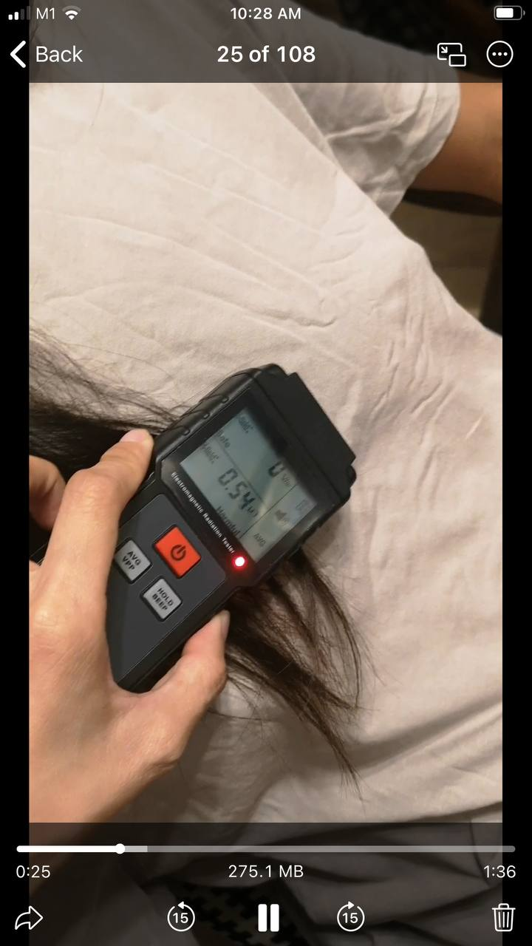
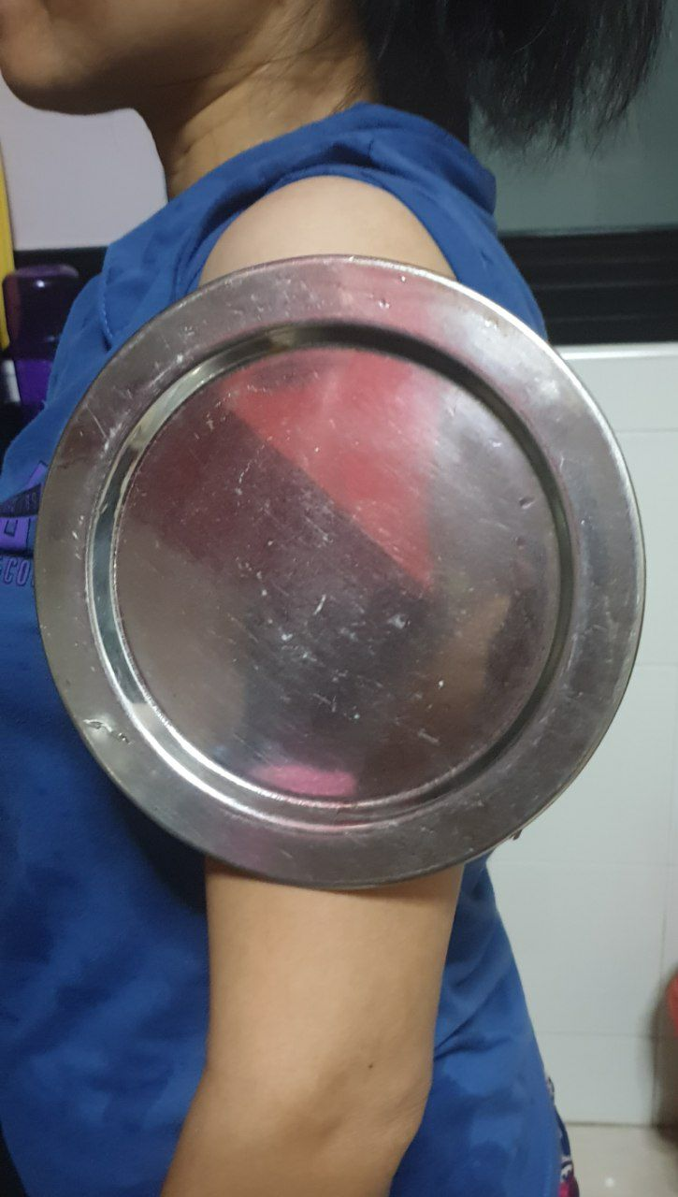
(case 29)

Appendix 3
(case 32)
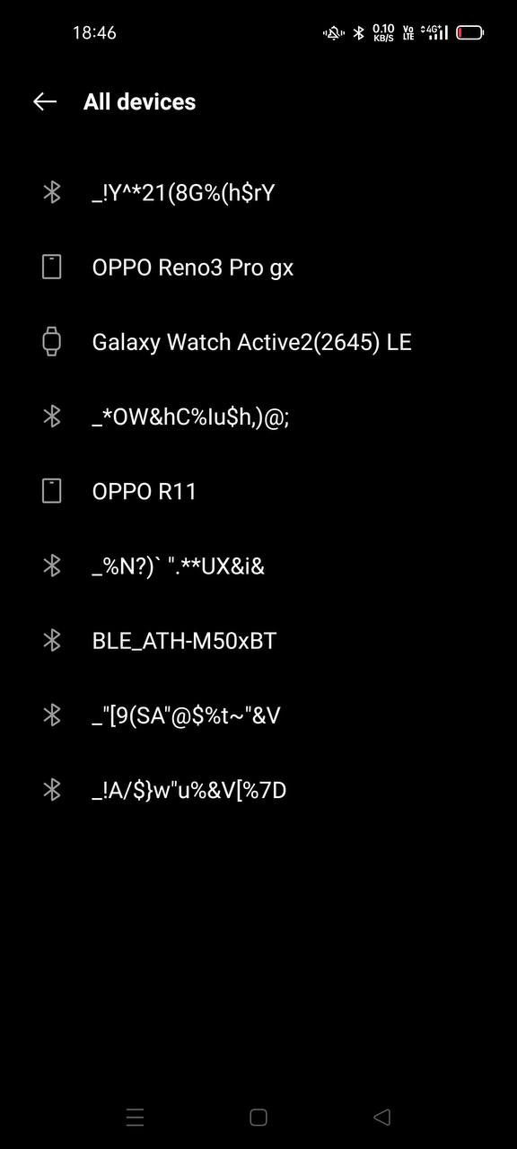
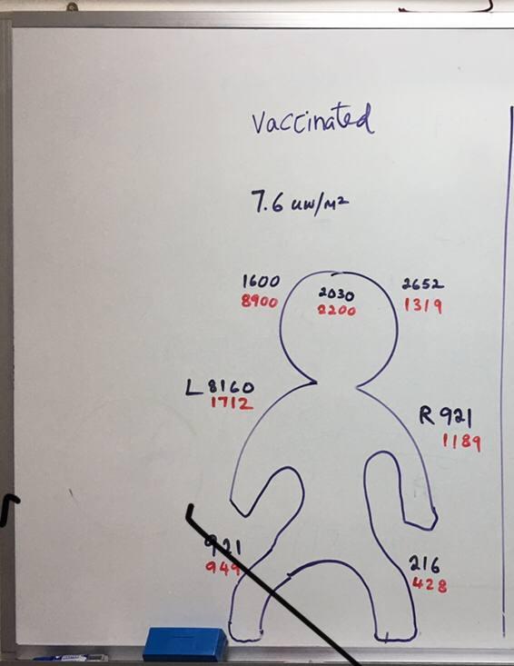
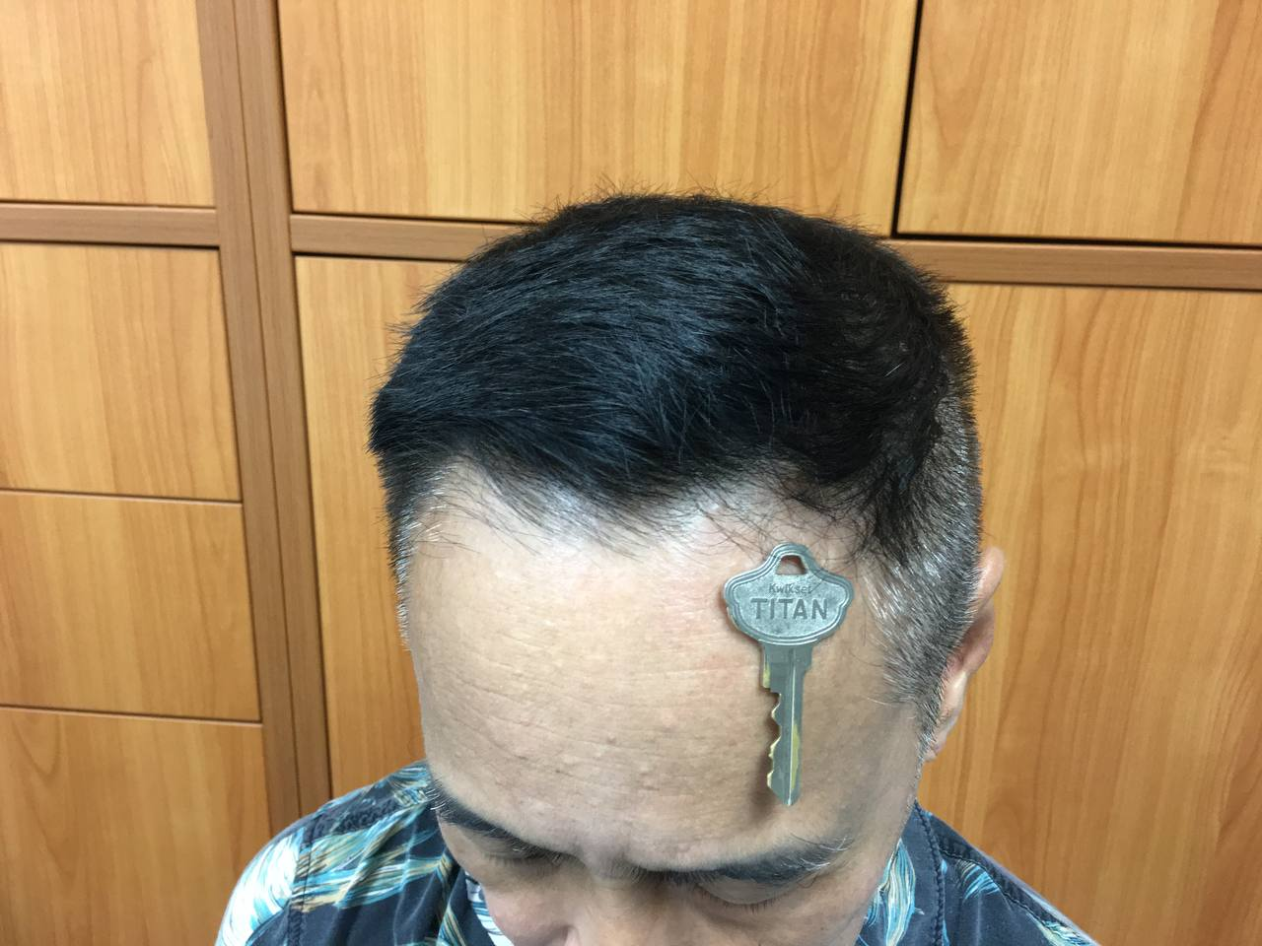

Appendix 4
case 32

Appendix 5
(case 30)
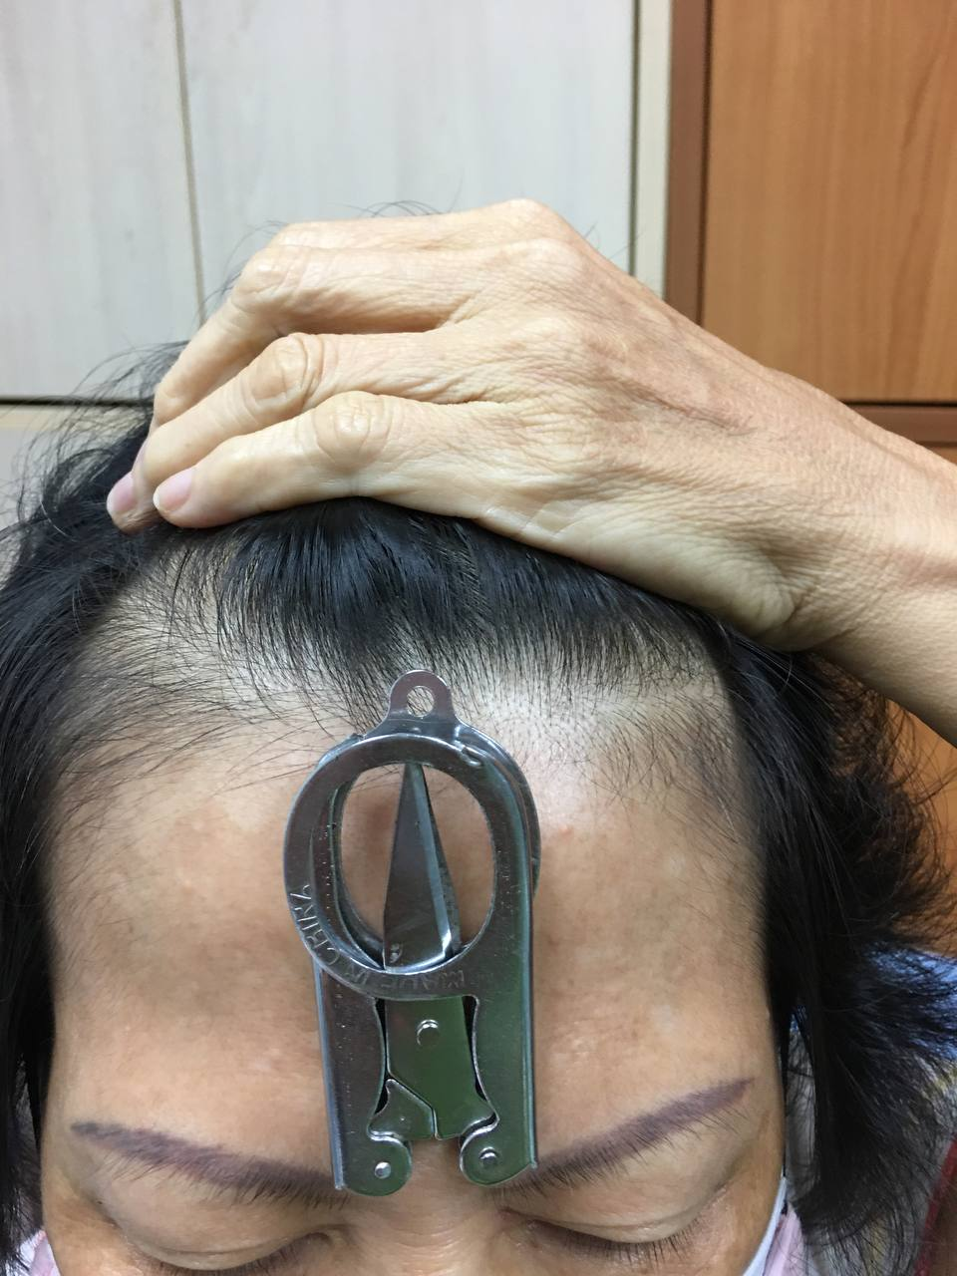

Appendix 6
(case 1)

Video https://t.me/SgTheMagneticGroup/3
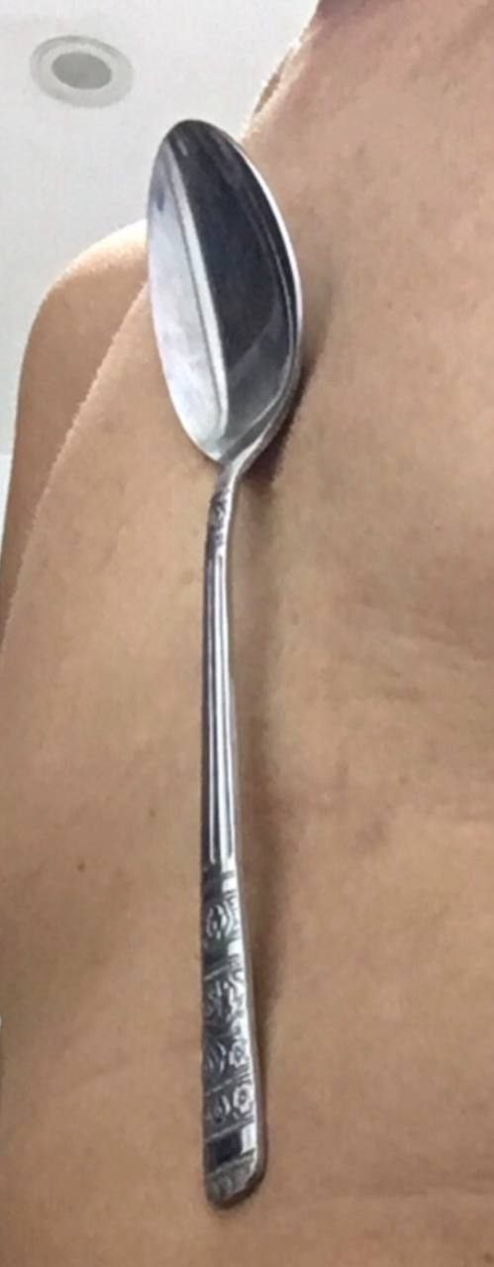

Appendix 7
(case 24)
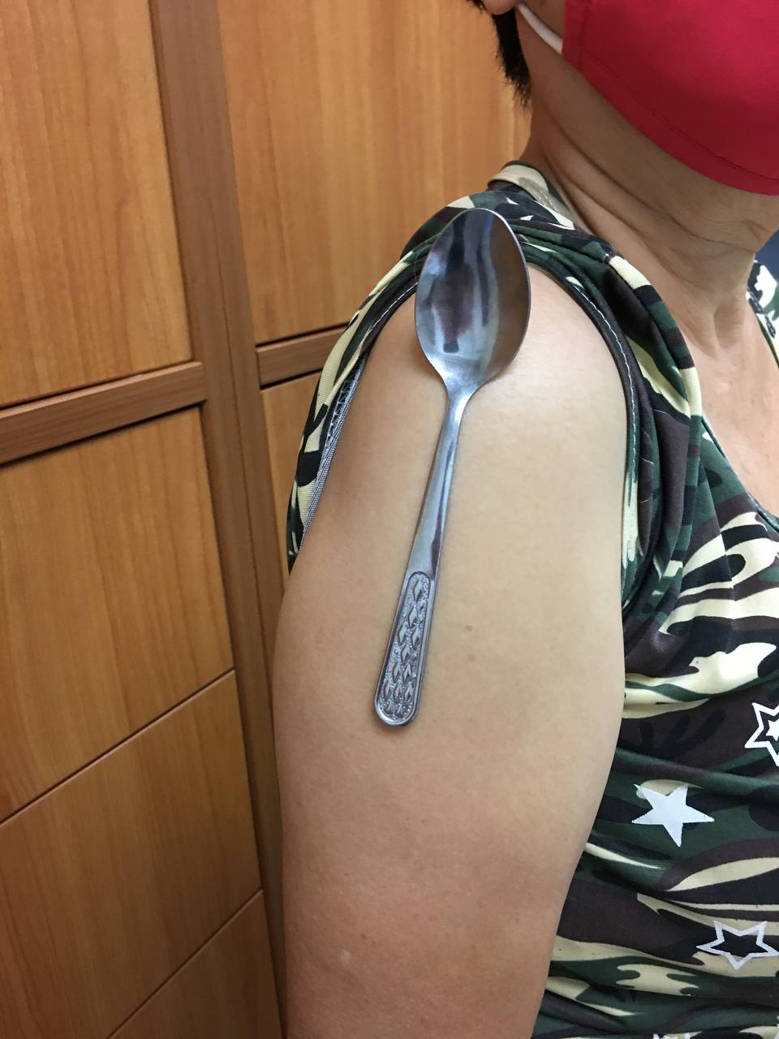
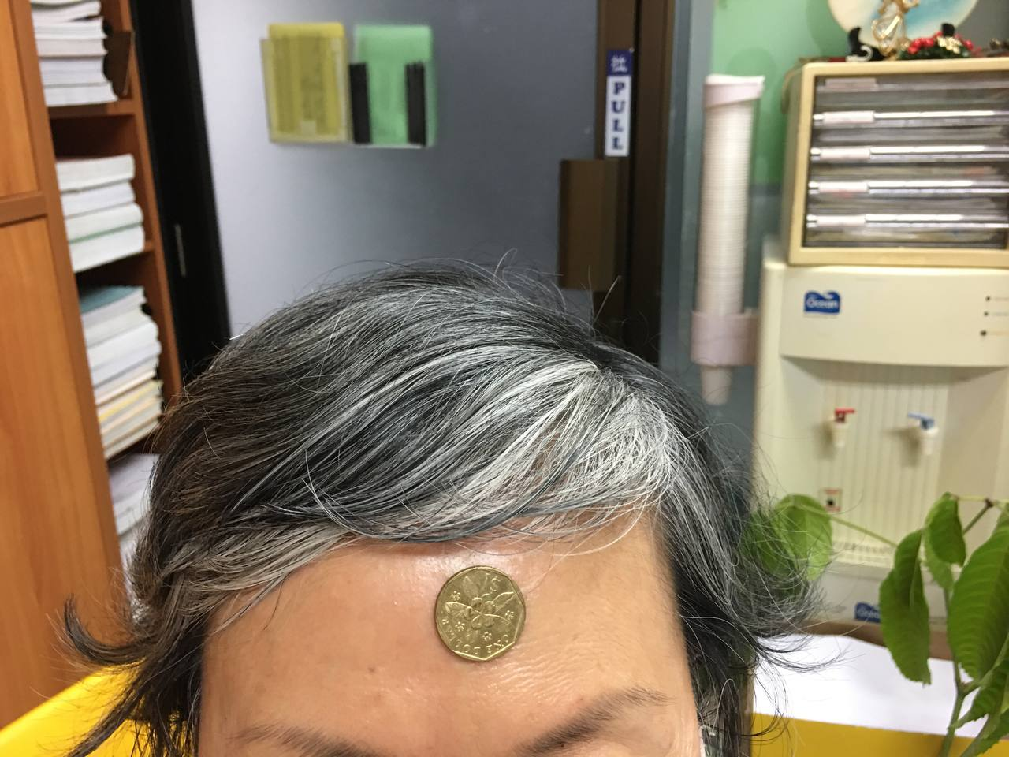
Appendix 9
(case 40)
Appendix 8 (case 27)
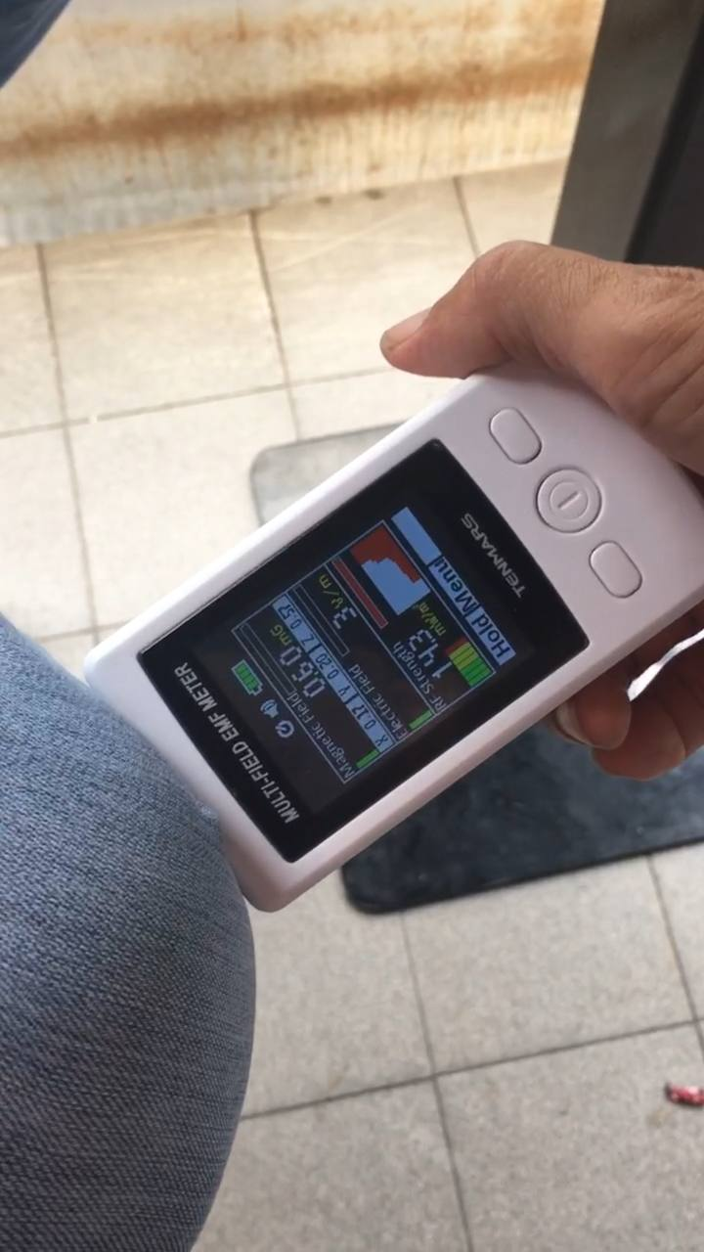

Video https://t.me/SgTheMagneticGroup/41
Appendix 10
(case 18)
e
Video https://t.me/SgTheMagneticGroup/68
Appendix 11
(Case1/Table 5)
